**G I d e l I n e**

Start XAMP control panel Apache and Mysql

* On browser: <http://localhost/sreyrot/yon_project%20-%20Copy/MVC-Scratch_IntegrateDahsboard1.2/>

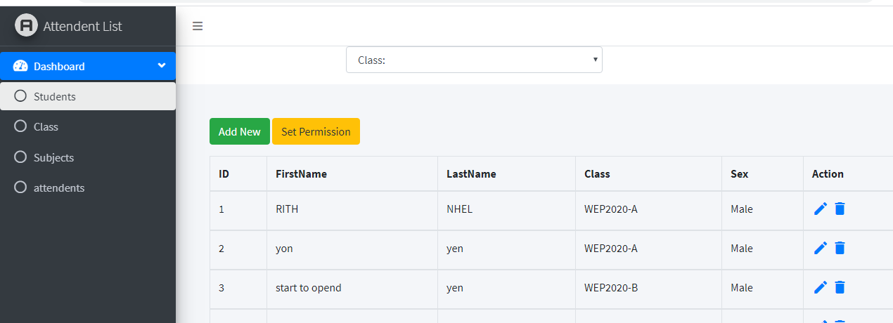

* This is the first interface of application
* Students:
* User can see all data of student by specific on class selection as WEP-A, WEP-B, SNA.
* User can **delete** the information of student by click on icons
* Click on icon edit to **edit** data

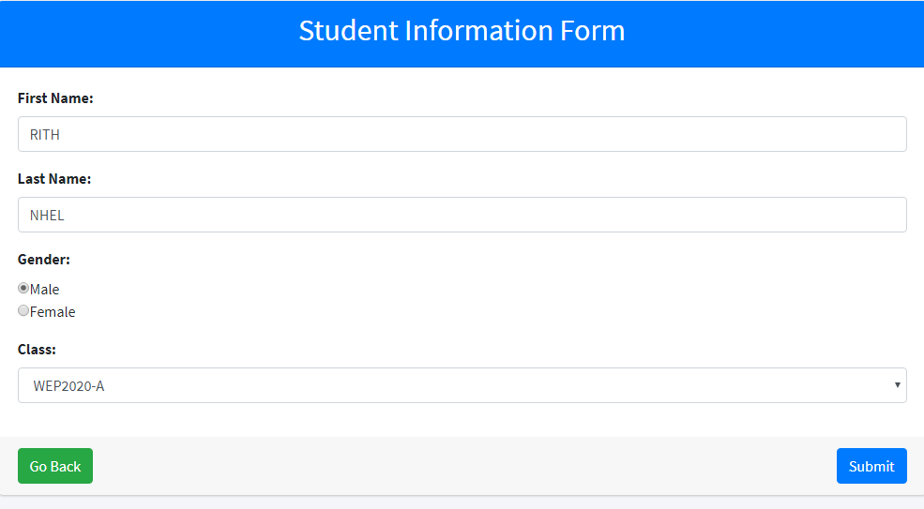

* User can click on Add New button to add more student
* User can click on **Add New** to add new data

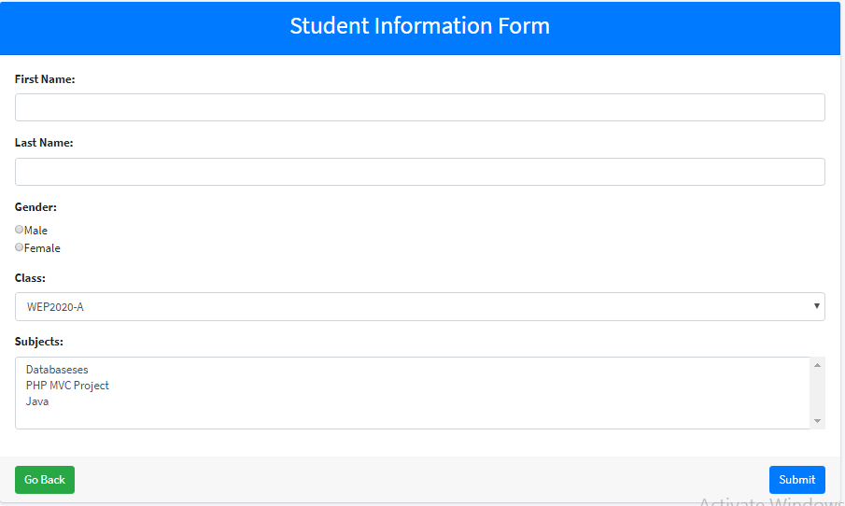

Then click **Submit**

* Class:

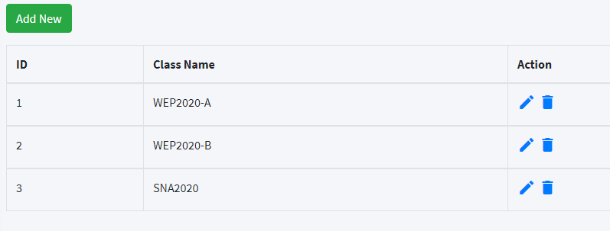

* Click **Add New** toadd new class
* Click on edit icons to edit data of class

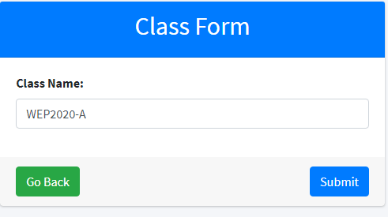

Then click Submit

* Click on icons **delete** to delete data

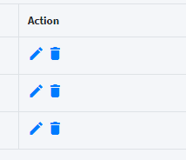

* Subject

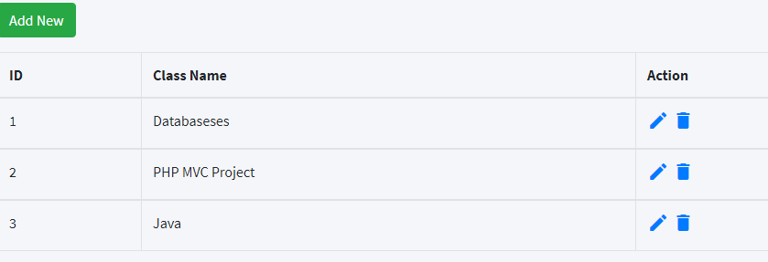

* Click on **Add New** to add new class

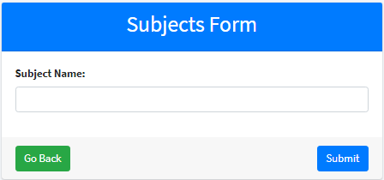

Then click Submit

* Click on icons **edit** to edit data

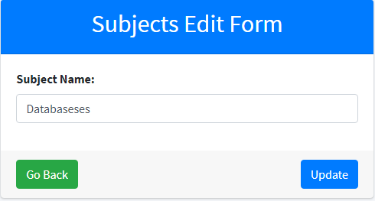

Then click Update

* Click on icon **delete** to delete data
* Attendant

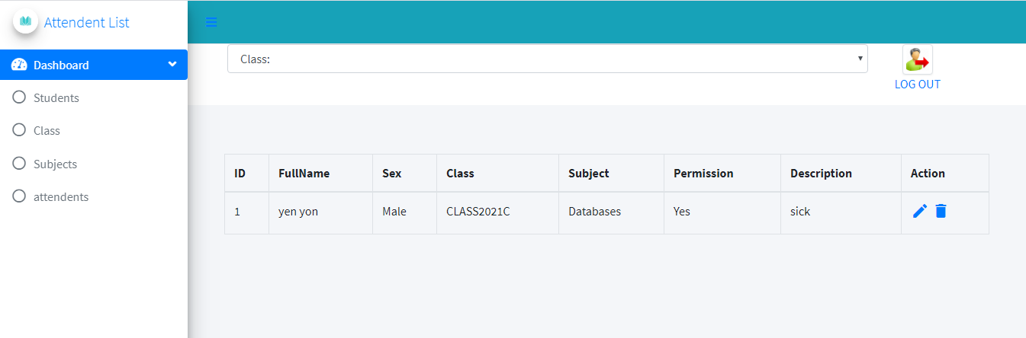

* This is view attendant, User can **delete** by click on icon delete